How to implement LaunchDarkly Feature flag

1. Install the javascript Client-side SDK with: npm install launchdarkly-js-client-sdk
2. Import the launchdarkly client into the application code ie: import * as LDclient from ‘launchdarly-js-client-sdk
3. Create a context (these contexts will be used if you want to use specific users with your feature) using this setup and then initialize the LaunchDarkly client. The first argument in the initialize is the client-side id found in your account settings/projects/environments, the second argument is the context that was created:

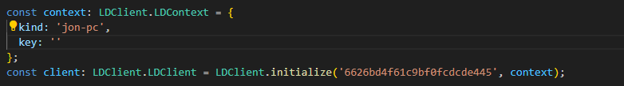

1. In this case we are going to be creating contexts on the fly (and changing as the users start logging in and out) so we will use the *identify* function like so:

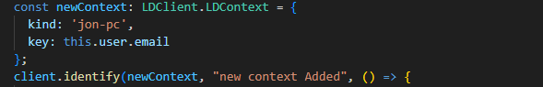

1. We are then passing the context into the callback function that will be run after the flags are updated with the new context. In this case we are focusing in on whether the remember me flag is on or off. It is here where we will see if the new context is able to pass our feature flag gates to use the newly created feature (window confirms). We accomplish this by using the ***variation***method where we can then compare our current client context with the targeted rule we set in the Launc Darkly webportal. If the targeted context matches the window will pop up, if not then you just login.

